



Email ID: [kailashkumarp78@gmail.com](mailto:kailashkumarp78@gmail.com) Contact No. +21-2030100206

To work for an organization which provides me the opportunity to improve my skills and knowledge to grow along with the organization objective.



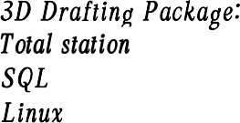

AutoCAD. flevit, E-tabs



* Highly motivated and eager to learn new things.
* Strong motivational and leadership skills.
* Ability to Produce best result in pressure situations.
* Excellent communication skills in written and verbal both.
* Ability to work as an individual as well as in a group.

from PACE institute of Technology,Ongole with 73% from Narayana Jr College, Kandukur with 23%

from Nagarjuna E.M High School, Kandukur with 20%

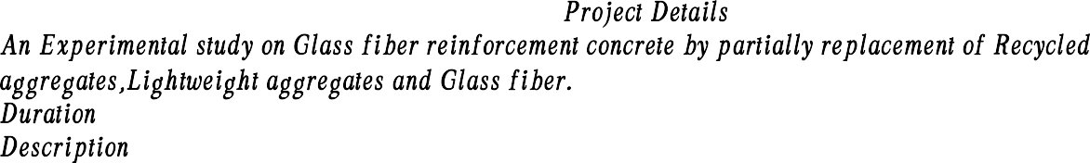

friendly.

: 3 Months

: At different dosages of materials increase the strength ,thermal resistance and eco-

* Hands on training in survey at Pace college Ongole.



Adventure Sports. Exploring places

fliding

Honest.

Hard Working. Positive Thinking.

flather Name Date Of flirth Sex

Marital status

Address

:P.Desharam

:16/02/1228

:Male

:Single

Nationality

LanguagesKnown

:fludida palem

Kandukur, Prakasam District,523105.

:Indian

: English, Telugu,Hindi

I hereby confirm that the information given above is true to the best of my knowledge.



* Attended a workshop on

 conducted by Institute of Technology and sciences.

* Attended Webinar On “ ” conducted by
* Attended Webinar on " ” conducted by flaghu institute of technology

MS Office, MS Excel.